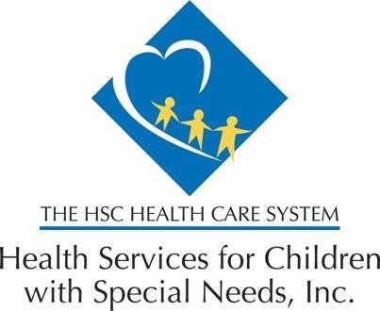

February 22, 2024

Dear Provider,

The purpose of this notice is to inform you of a recent cyber-attack incident that has impacted operations at Health Services for Children with Special Needs, Inc. (HSCSN)

HSCSN holds a contract with Change Healthcare; a technology vendor that offers an array of financial, revenue cycle, and clinical informatic solutions to health plans and health care providers across the country. Today, we were made aware of a cyber security event with Change Healthcare. In response to this cyber event, Change Healthcare took immediate action to disconnect systems and data feeds to prevent further risk of impact to health care clients and patients. We expect this to be a temporary disruption, however as of close of business Thursday February 22, 2024, it has been reported as unresolved.

As a result of the cyber security risk, HSCSN must implement a temporary pause of those operational functions supported by Change Healthcare. The temporary pause includes:

- Electronic claims submission: HSCSN cannot receive claims and we encourage providers to discontinue use of their Change Healthcare connections to attempt claims submission at this time.
- Electronic Funds Transfer (EFT), ACH, and check payments: HSCSN is unable to make claims payments to providers until this issue is resolved.
- Online Eligibility Verification: Providers are unable to check real-time HSCSN enrollee eligibility.
- Online Claims Status: Providers are unable to check claims status for HSCSN claims.

Steps for Providers to take to safeguard their practices and stay informed as this risk is being researched and resolved:
- Providers are highly encouraged to not use their saved username and passwords, to access any Change Healthcare products, and are encouraged to clear their cache, and cookies, for any Change healthcare related information.
- Providers can subscribe to real-time updates from Change Healthcare at https://status.changehealthcare.com/incidents/hqpjz25fn3n7#
Until this issue is resolved by Change Healthcare, providers may use the following alternatives to verify eligibility, benefits, submission of claims and check claims status:
- Providers can reach HSCSN’s Customer Care Team at (202)467-2737.
- Providers can drop claims on paper and submit them to HSCSN at: Health Services for Children with Special needs; P.O. Box 29055 Washington, DC. 20017

HSCSN will continue to monitor the status of the disruption over the next 24 hours and determine the next steps towards business continuity and security safeguards, as appropriate. HSCSN is exploring optimal claims payment alternatives should claims payment processes continue to be impacted. Should you have any questions, please contact your Provider Relations Representative.

Sincerely,
Chief Operating Officer, HSCSN

