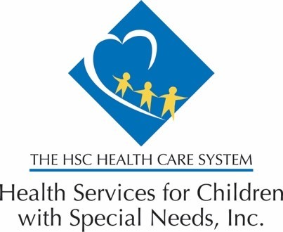

Dear Parents and Caregivers,
We are writing to let you know about a recent recall of certain apple sauce pouches due to possible contamination with lead. The affected products are:
- WanaBana apple cinnamon fruit puree pouches (all lot codes and expiration dates)
- Schnucks-brand cinnamon-flavored applesauce pouches and variety pack
- Weis-brand cinnamon applesauce pouches
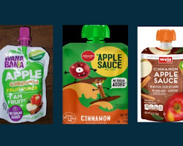
www.mesacounty.us
Schnucksbrand cinnamonflavored applesauce pouches
What you need to do:
- Do not buy or feed your child any of the affected products.
- Throw away any recalled products that you may have in your home.
- Contact your child's Primary Care Provider (PCP) if you think your child may have eaten any of the recalled products. They will advise you on the next steps, which may include blood testing to check for lead levels.
Why this is important:
Lead is a toxic metal that can be harmful to children's health, even at low levels. Exposure to lead can cause some health problems, including:
- Developmental delays
- Learning problems
- Behavior problems
- Hearing loss
- Anemia
Additional information:
For more information about the recall, please visit the following websites:
- FDA: https://nypost.com/2023/10/30/business/fda-warns-of-extremely-high-lead-levels-in-wanabana-fruit-pouches/
- CDC: https://emergency.cdc.gov/han/2023/han00500.asp
We understand that this news may be concerning. We want to assure you that the Environmental Protection Agency (EPA) and the Food and Drug Administration (FDA) are working to identify the source of the contamination to ensure that safe products are available to all children.
If you need more information or help to schedule an appointment with your child’s doctor, please contact our Enrollee Services Helpline at 202-467-2737.
We encourage you to share this information with other parents and caregivers in your community.

